|  |  |  |
| --- | --- | --- |
| Nama | : | Fatimah Ulwiyatul Badriyah |
| NIM | : | 1157050053 |
| Kelas | : | IF-B |
| Tugas ke | : | 2 |
| Mata Kuliah | : | Praktikum Pengembangan Aplikasi Web |
| Alamat Web | : | fweb07.000webhostapp.com |

**TUGAS WIREFRAMING**

**Mockup Wireframe**

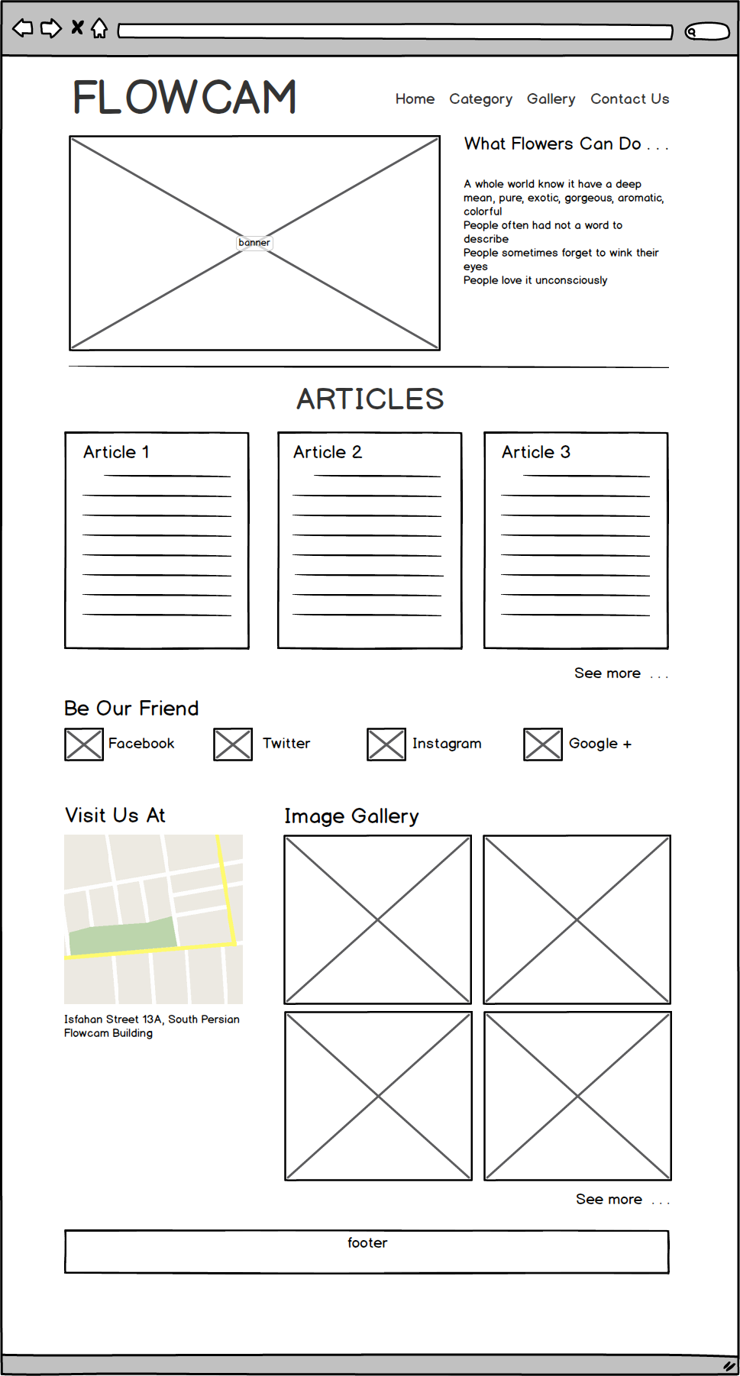

**Hasil Screenshot**

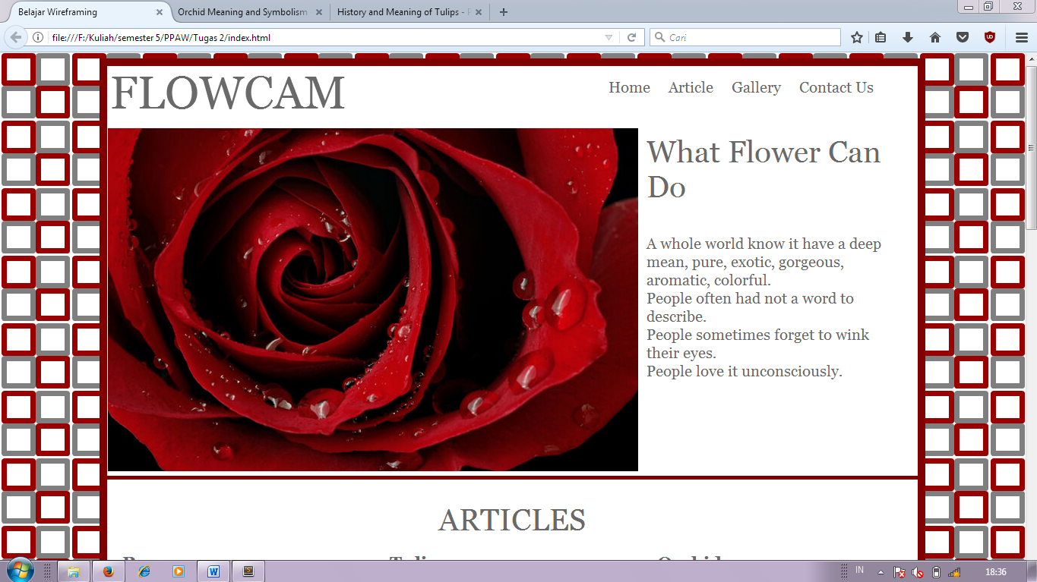

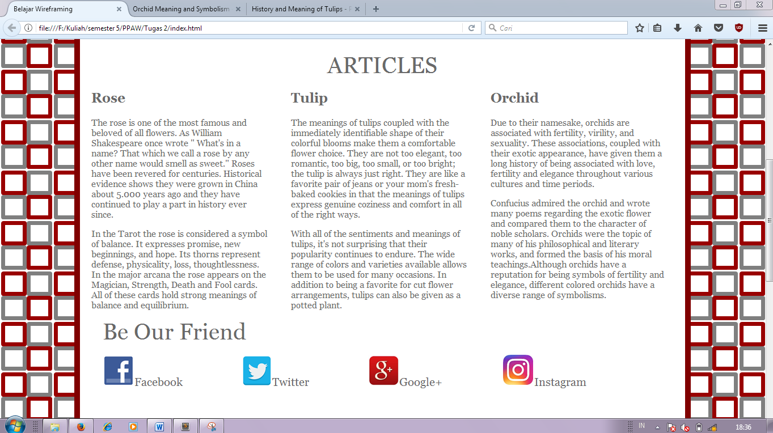

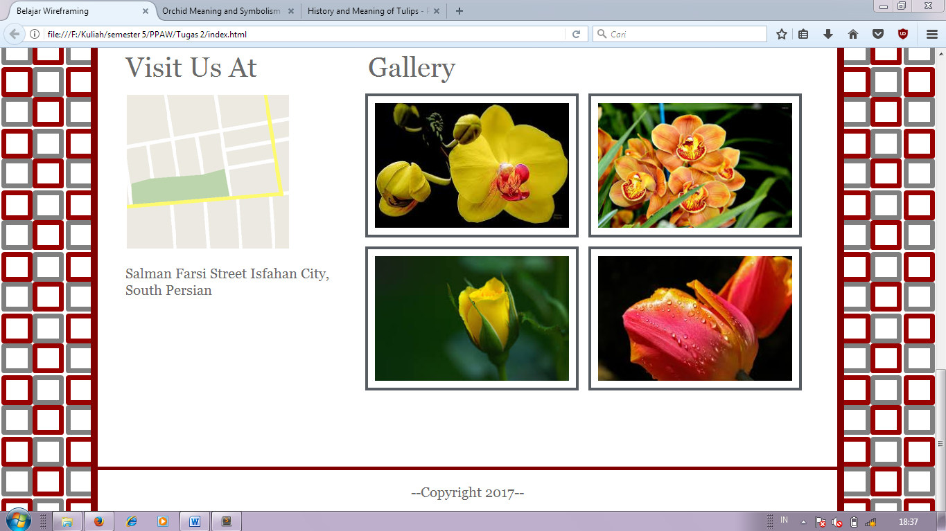

**Source Codes**

<!DOCTYPE html>

<html>

<head>

<title>Belajar Wireframing</title>

<link rel="stylesheet" type="text/css" href="https://fonts.googleapis.com/cssfamily?family=Oldenburg">

<style type="text/css">

body{

background-image: url("images/bg2.png");

}

.wrapper{

background-color: white;

width: 80%;

margin: 0px auto 0px auto;

font-family: georgia;

color: #696969;

border: 10px solid maroon;

}

header{

height: 80px;

}

#judul{

height: 80px;

width: 30%;

float: left;

margin-top: 10px 0px 0px 0px;

}

nav{

height: 80px;

width: 69.5%;

float: left;

}

ul li{

display: inline;

}

nav ul li a{

text-decoration: none;

font-size: 20px;

color: #696969;

padding-left: 20px;

}

#banner{

height: 460px;

}

.img{

height: 460px;

width: 700px;

float: left;

}

.img img{

height: 455px;

width: 700px;

}

.words{

height: 460px;

width: 358px;

float: left;

}

article{

height: 500px;

margin: none;

border-top: 5px solid maroon;

}

.article1, .article2, .article3{

height: 350px;

width: 312px;

float: left;

margin: 0px 20px 20px 20px;

}

section{

height: 850px;

}

.sosmed{

height: 250px;

}

.sosmed ul li a{

padding: none;

margin: none;

padding-right: 100px;

text-decoration: none;

font-size: 20px;

color: #696969;

}

.peta{

height: 595px;

width: 350px;

float: left;

}

.gallery{

height: 595px;

width: 708px;

float: left;

}

#album{

width: 647px;

margin: 10px auto;

}

#album img{

border: 4px solid #575D63;

margin: 5px;

padding: 10px;

width: 280px;

height: 180px;

}

footer{

height: 50px;

text-align: center;

font-size: 20px;

padding-top: 20px;

border-top: 5px solid maroon;

}

</style>

</head>

<body>

<!--Ini Wrapper-->

<div class="wrapper">

<!--Ini Header-->

<header>

<!--Ini Judul Web-->

<div id="judul" style="font-size:60px; text-align:center;">

FLOWCAM

</div>

<!--Ini Menu Navigasi-->

<nav>

<ul>

<li style="margin-left: 280px;"><a href="#">Home</a></li>

<li><a href="#">Article</a></li>

<li><a href="#">Gallery</a></li>

<li><a href="#">Contact Us</a></li>

</ul>

</nav>

</header>

<!--Akhir Header-->

<!--Ini Banner-->

<div id="banner">

<!--Ini Untuk Foto-->

<div class="img">

<img src="images/banner.png" style:"height:450px">

</div>

<!--Ini Untuk Tulisan-->

<div class="words">

<div style="font-size:40px; padding:10px;">

What Flower Can Do

</div>

<div style="font-size:20px; padding:10px;">

<p>A whole world know it have a deep mean, pure, exotic, gorgeous, aromatic, colorful.

<br/>

People often had not a word to describe.

<br/>

People sometimes forget to wink their eyes.

<br/>

People love it unconsciously.</p>

</div>

</div>

</div>

<!--Akhir Banner-->

<!--Ini Article-->

<article>

<p style="font-size:40px; text-align:center; margin:0px; padding-top:30px;">ARTICLES</p>

<div class="article1">

<h1>Rose</h1>

<p>The rose is one of the most famous and beloved of all flowers. As William Shakespeare once wrote &#34; What&#39;s in a name? That which we call a rose by any other name would smell as sweet.&#34; Roses have been revered for centuries. Historical evidence shows they were grown in China about 5.000 years ago and they have continued to play a part in history ever since.</p>

<p>In the Tarot the rose is considered a symbol of balance. It expresses promise, new beginnings, and hope. Its thorns represent defense, physicality, loss, thoughtlessness. In the major arcana the rose appears on the Magician, Strength, Death and Fool cards. All of these cards hold strong meanings of balance and equilibrium.</p>

</div>

<div class="article2" style:"padding:10px;">

<h1>Tulip</h1>

<p >The meanings of tulips coupled with the immediately identifiable shape of their colorful blooms make them a comfortable flower choice. They are not too elegant, too romantic, too big, too small, or too bright; the tulip is always just right. They are like a favorite pair of jeans or your mom&#39;s fresh-baked cookies in that the meanings of tulips express genuine coziness and comfort in all of the right ways.</p>

<p>With all of the sentiments and meanings of tulips, it&#39;s not surprising that their popularity continues to endure. The wide range of colors and varieties available allows them to be used for many occasions. In addition to being a favorite for cut flower arrangements, tulips can also be given as a potted plant.</p>

</div>

<div class="article3">

<h1>Orchid</h1>

<p>Due to their namesake, orchids are associated with fertility, virility, and sexuality. These associations, coupled with their exotic appearance, have given them a long history of being associated with love, fertility and elegance throughout various cultures and time periods.</p>

<p>Confucius admired the orchid and wrote many poems regarding the exotic flower and compared them to the character of noble scholars. Orchids were the topic of many of his philosophical and literary works, and formed the basis of his moral teachings.Although orchids have a reputation for being symbols of fertility and elegance, different colored orchids have a diverse range of symbolisms.</p>

</div>

</article>

<!--Akhir Article-->

<!--Ini Section-->

<section>

<div class="sosmed">

<p style="font-size:40px; padding-left:40px; margin:0px;" >Be Our Friend</p>

<ul>

<li><a href="#"><img src="images/fb.png">Facebook</a></li>

<li><a href="#"><img src="images/twitter.png">Twitter</a></li>

<li><a href="#"><img src="images/g+.png">Google+</a></li>

<li><a href="#"><img src="images/ig.png">Instagram</a></li>

</ul>

</div>

<div class="peta">

<p style="font-size:40px; padding-left:40px; margin:0px;">Visit Us At</p>

<a href="#"><img src="images/peta.png" style="padding-left:40px; padding-top:15px;"></a>

<p style="font-size:20px; padding-left:40px;">Salman Farsi Street Isfahan City, South Persian</p>

</div>

<div class="gallery">

<p style="font-size:40px; padding-left:40px; margin:0px;">Gallery</p>

<div id="album">

<img src="images/img-gal1.jpg">

<img src="images/img-gal2.jpg">

<img src="images/img-gal3.jpg">

<img src="images/img-gal4.jpg">

</div>

</div>

</section>

<!--Akhir Section-->

<!--Ini Footer-->

<footer>

--Copyright 2017--

</footer>

<!--Akhir Footer-->

</div>

<!--Akhir Wrapper-->

</body>

</html>